Download the Scrip app called RaiseRight!
With every purchase, St. John’s receives a percent of your total purchase.

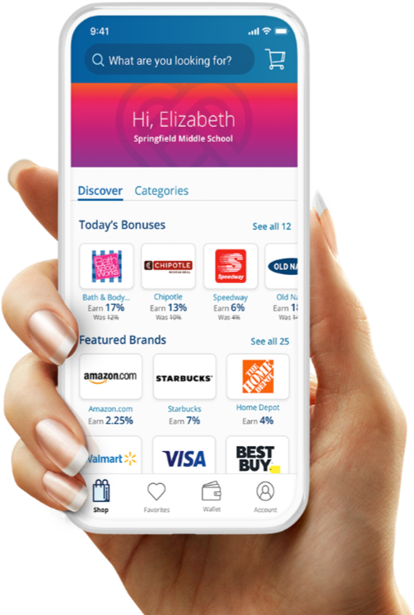
Simply the Right
Way to Fundraise

The new RaiseRight™ mobile app makes fundraising easier
Shop gift cards from more than 750 top brands—right from your phone. Whether you’re at home or at the store. Get started with on-the-go fundraising that creates opportunities for the people that matter most to you.

Narrow your search with categories that fit your everyday shopping needs.
Discover new earning opportunities every day!

Easily browse brands offering bonus earnings!
Add brands you love to your Favorites for faster shopping.
Manage your gift cards in one place: your Wallet.
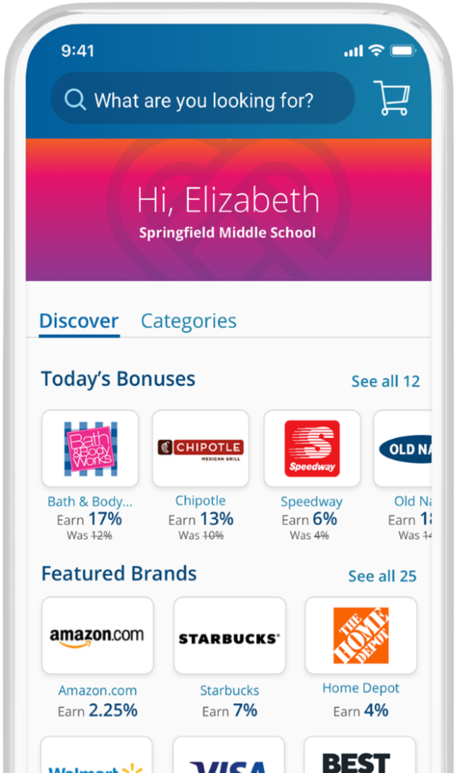
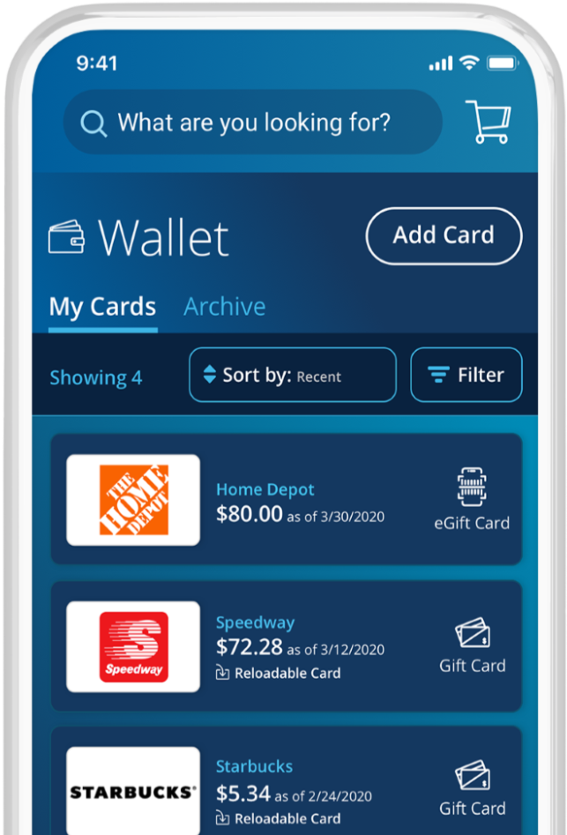

www.RaiseRight.com

St. John’s
United Church of Christ, Schwarzwald
Enrollment Code:
8A5B37A67L23

The Church Secretary, Vicki has downloaded and used the app.
She has found it is very easy to use.
If you have any questions, please contact her
at 920-565-2631 or 920-331-4586.

Download the app, place an order before September 12 and
you are entered for a chance to win a $1,500 gift card package!
